**Intelligent Courier Logistics Engine**

**Session 2024 - 2028**

**Submitted By:**

**Muhammad Ayan Sajid 2024 CS 661**

**Shehroz Shafaqat 2024 CS 690**

**Shareen Asim 2024 CS 693**

**Fiza Shahid Khan 2024 CS 680**

**Submitted To:**

**Mr. Ali Raza**

**Department of Computer Science, UET Lahore, New Campus**

**Table of Contents**

1 Introduction 4

2 Project Overview 4

3 UML Diagram 5

3.1 Class Diagram 5

4 Flowcharts 6

4.1 Main Application Flowchart 6

4.2 Add Parcel Flowchart 7

4.3 Dispatch Parcel Flowchart 8

4.4 Dijkstra’s Shortest Path Algorithm Flowchart 9

4.5 K-Shortest Paths Algorithm Flowchart 10

4.6 Record Delivery Attempt Flowchart 11

4.7 Assign Parcel to Rider Flowchart 12

4.8 Find Best Rider Flowchart 13

4.9 Undo Operation Flowchart 14

4.10 Block/Unblock Road Flowchart 15

4.11 Parcel Lifecycle Flowchart 16

4.12 Queue Operations (Pickup/Warehouse/Transit) Flowchart 17

4.13 MinHeap Insert Operation Flowchart 17

4.14 MinHeap Extract Min Operation Flowchart 18

4.15 HashMap Insert Operation Flowchart 19

4.16 Zone Auto-Assignment Flowchart 20

4.17 Save/Load Parcels Flowchart 21

4.18 WebServer Request Handling Flowchart 21

5 System Architecture Diagram 22

6 System Architecture 22

7 File and Module Description 22

7.1 main.cpp 22

7.2 Parcel.h 23

7.3 ParcelManager.h / ParcelManager.cpp 23

7.4 Graph.h / Graph.cpp 23

7.5 CourierOperations.h / CourierOperations.cpp 24

7.6 structures.h 24

7.7 ValidationUtils.h 25

7.8 WebServer.h / WebServer.cpp 25

7.9 JsonUtils.h 25

7.10 Input/Output Files 25

7.11 public/ (Web UI) 26

8 Data Structures and Algorithms Justification 26

8.1 Data Structures Used: 26

8.2 Algorithms Used: 27

8.3 Complexity Analysis: 27

9 Conclusion 27

**Table of Figures**

Figure 1 Class Diagram 5

Figure 2 Main Application Flowchart 6

Figure 3 Add Parcel Flowchart 7

Figure 4 Dispatch Parcel Flowchart 8

Figure 5 Dijkstra's Shortest Path Algorithm Flowchart 9

Figure 6 K-Shortest Path Algorithm Flowchart 10

Figure 7 Record Delivery Attempt Flowchart 11

Figure 8 Assign Parcel to Rider Flowchart 12

Figure 9 Find Best Rider Algorithm 13

Figure 10 Undo Operation Flowchart 14

Figure 11 Block/Unblock Road Flowchart 15

Figure 12 Parcel Lifecycle Flowchart 16

Figure 13 Queue Operations (Pickup/Warehouse/Transit) Flowchart 17

Figure 14 MinHeap Insert Operation 17

Figure 15MinHeap Extract Min Operation Flowchart 18

Figure 16 HashMap Insert Operation Flowchart 19

Figure 17 Zone Auto-Assignment Flowchart 20

Figure 18 Save/Load Parcels Flowchart 21

Figure 19 WebServer Request Handling Flowchart 21

Figure 20 System Architecture Diagram 22

# Introduction

The goal of this project is to design and implement an **Intelligent Parcel Sorting, Routing, and Tracking System** for a courier logistics company. The system uses appropriate data structures and algorithms to manage parcel sorting, route selection, tracking, and courier operations efficiently. Through this project, real-world logistics problems are addressed while demonstrating problem-solving skills, structured program design, and ethical computing practices using C++.

# Project Overview

***The Intelligent Courier Logistics Engine*** is a C++–based simulation system developed to model real-world courier logistics operations. The system automates parcel sorting, route computation, tracking, and courier workflow management using fundamental Data Structures and Algorithms. It is designed as a menu-driven CLI application that processes parcel and map data from input files and performs intelligent decision-making to ensure efficient delivery operations.

# UML Diagram

## Class Diagram

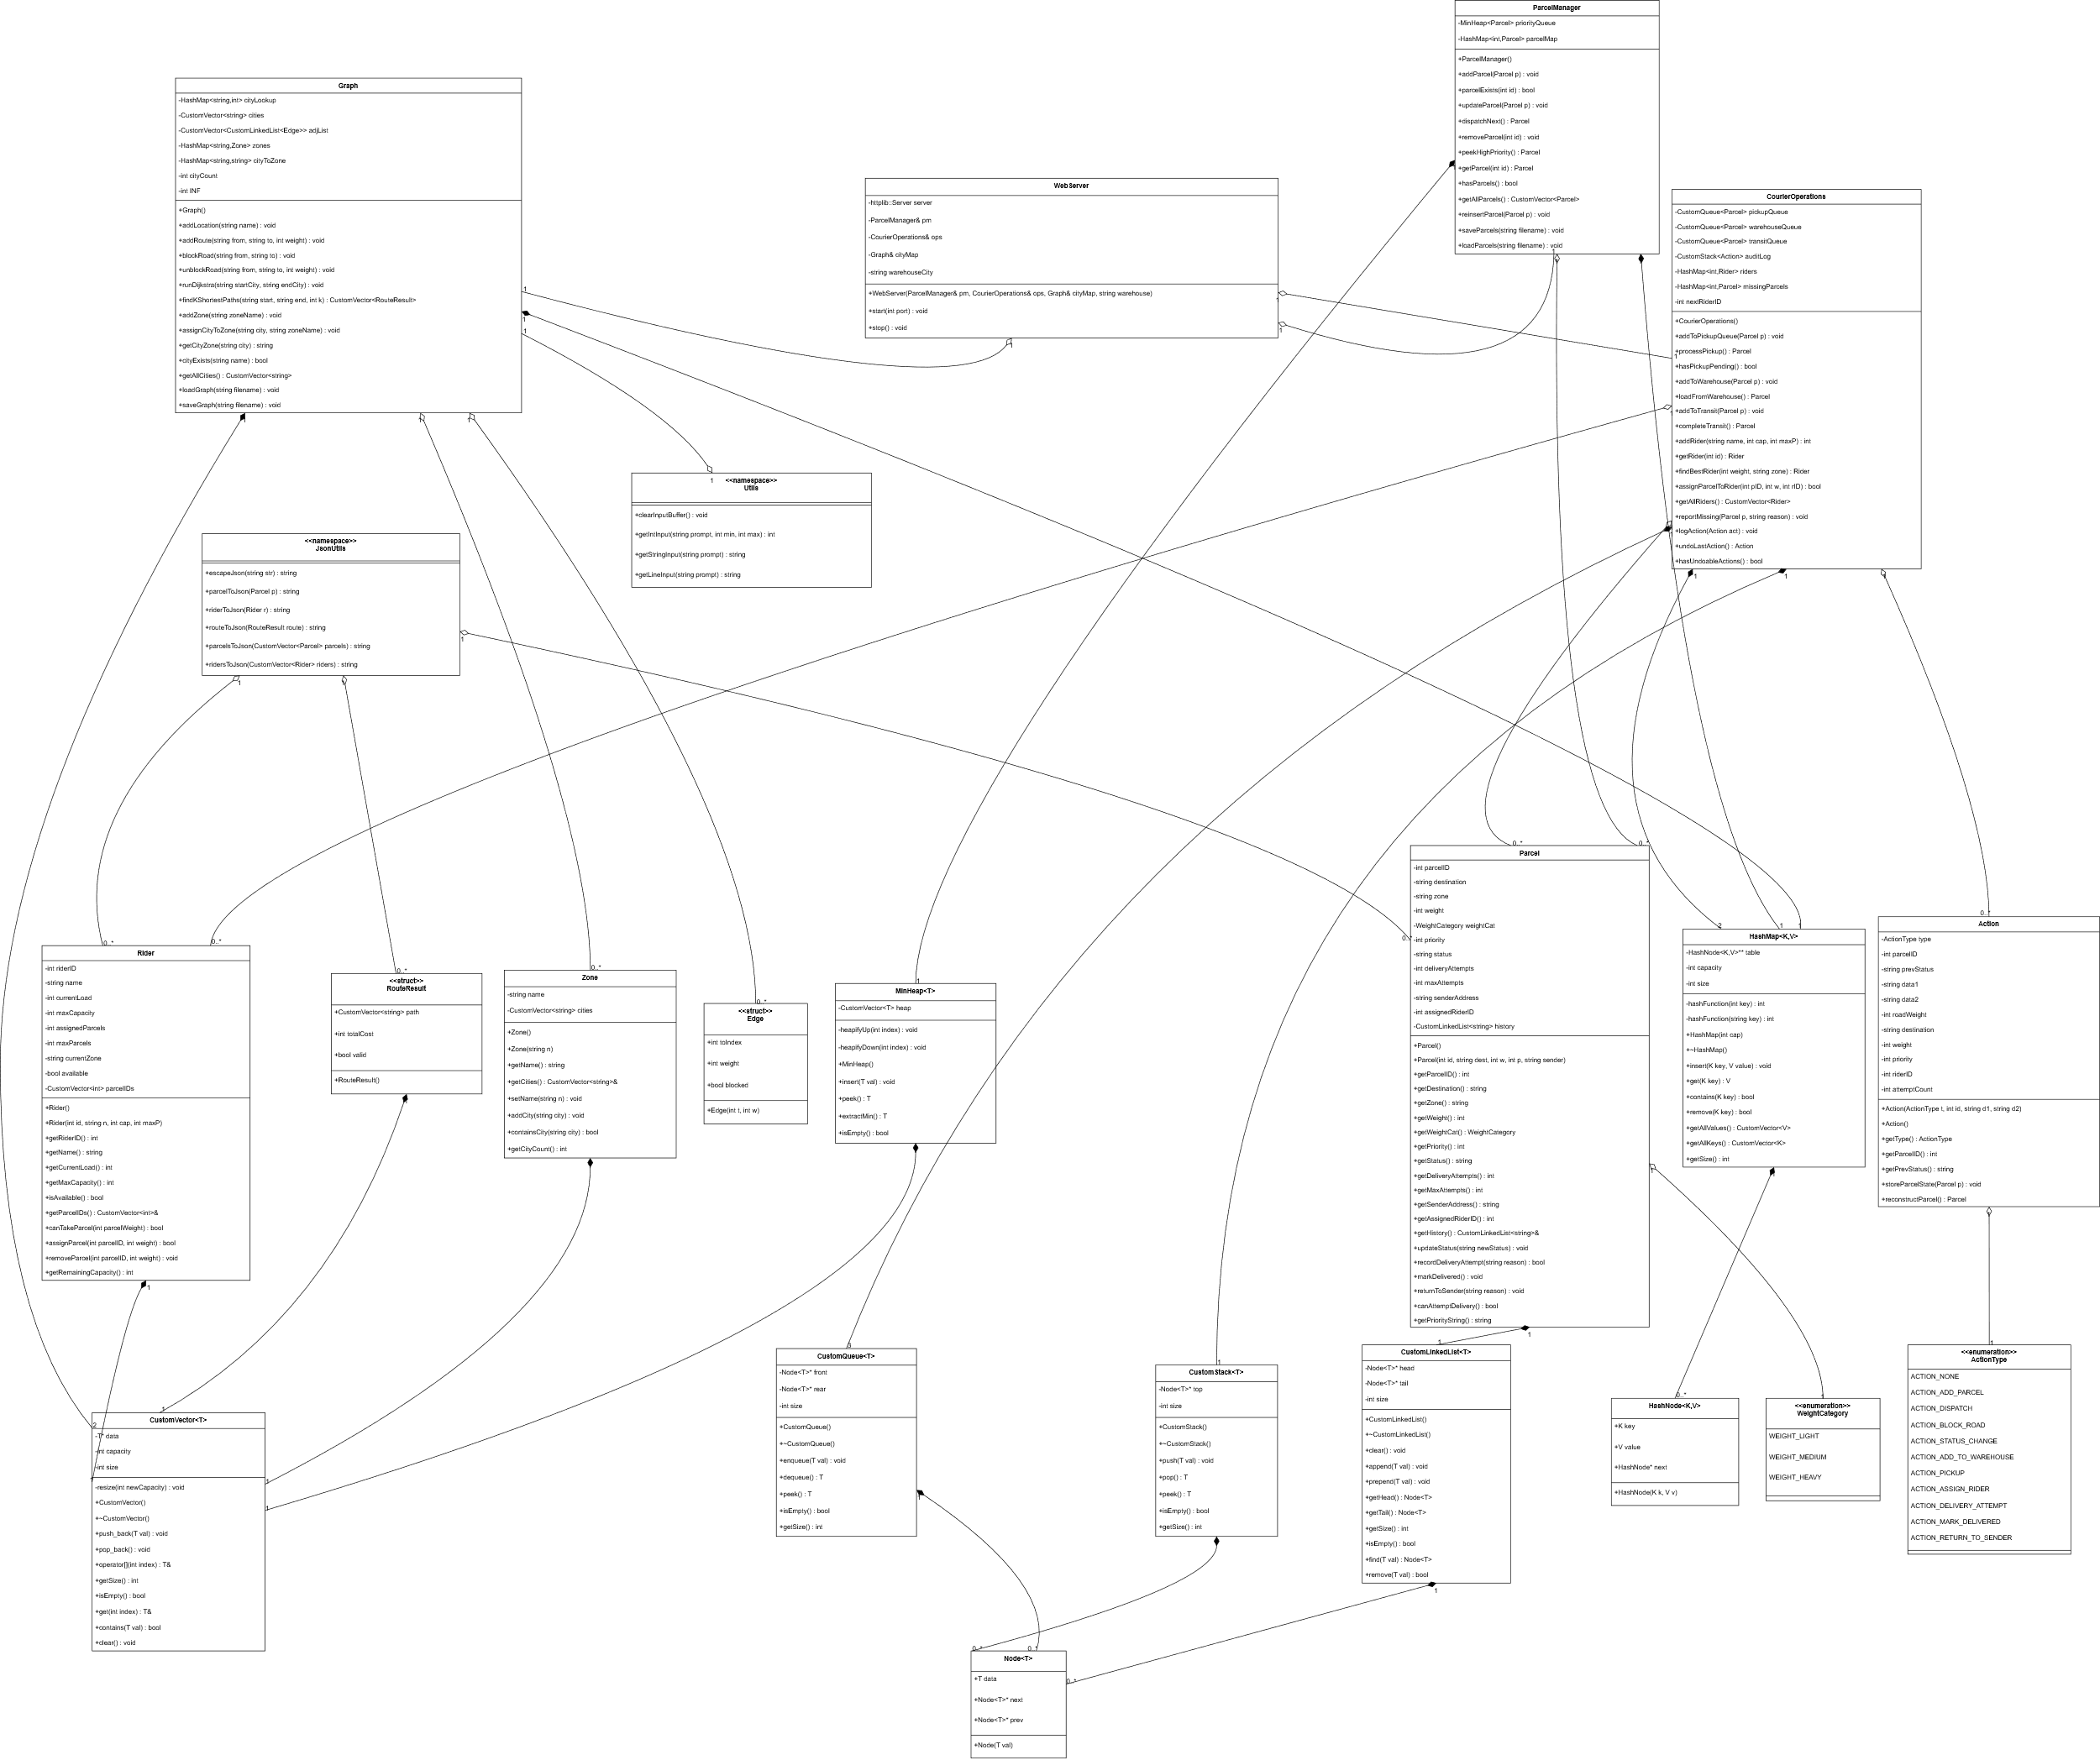

Figure 1 Class Diagram

# Flowcharts

## Main Application Flowchart

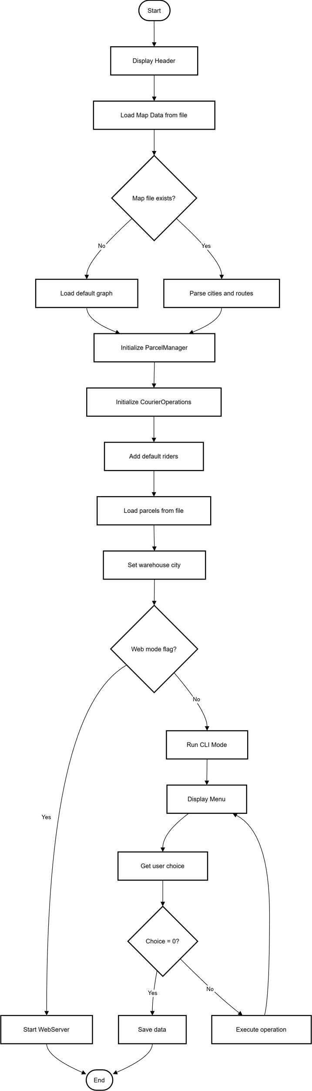

Figure Main Application Flowchart

## Add Parcel Flowchart

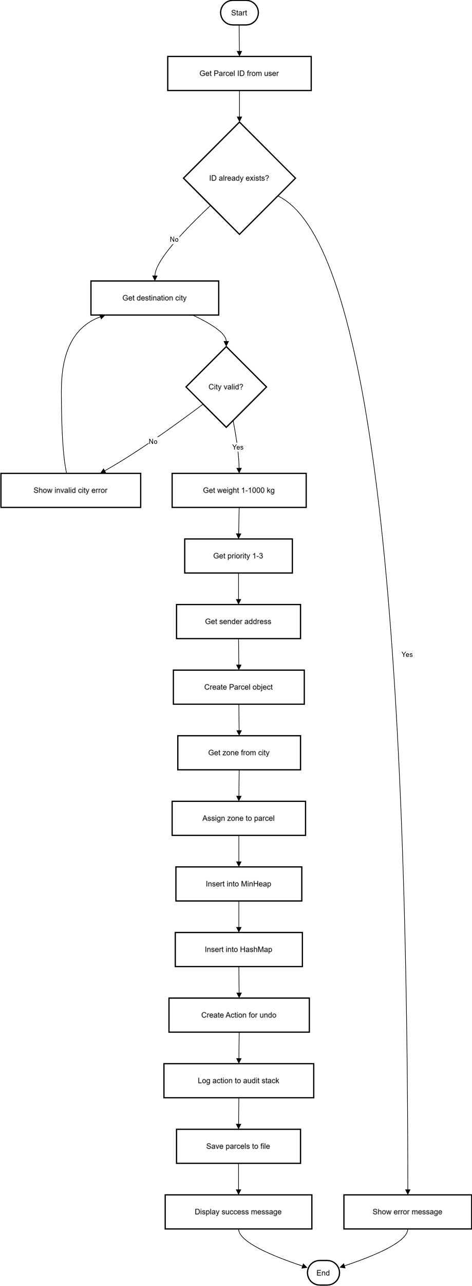

Figure 3 Add Parcel Flowchart

## Dispatch Parcel Flowchart

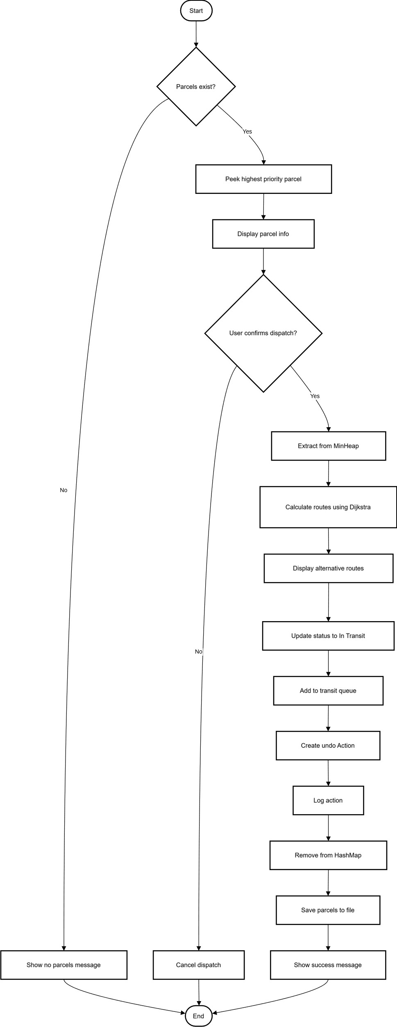

Figure Dispatch Parcel Flowchart

## Dijkstra’s Shortest Path Algorithm Flowchart

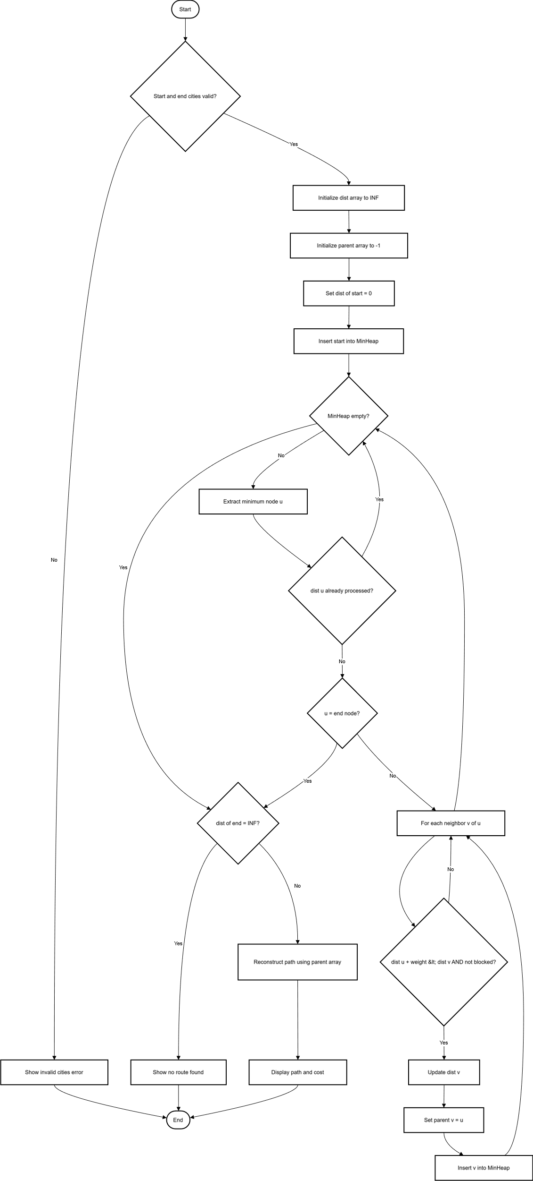

Figure 5 Dijkstra's Shortest Path Algorithm Flowchart

## K-Shortest Paths Algorithm Flowchart

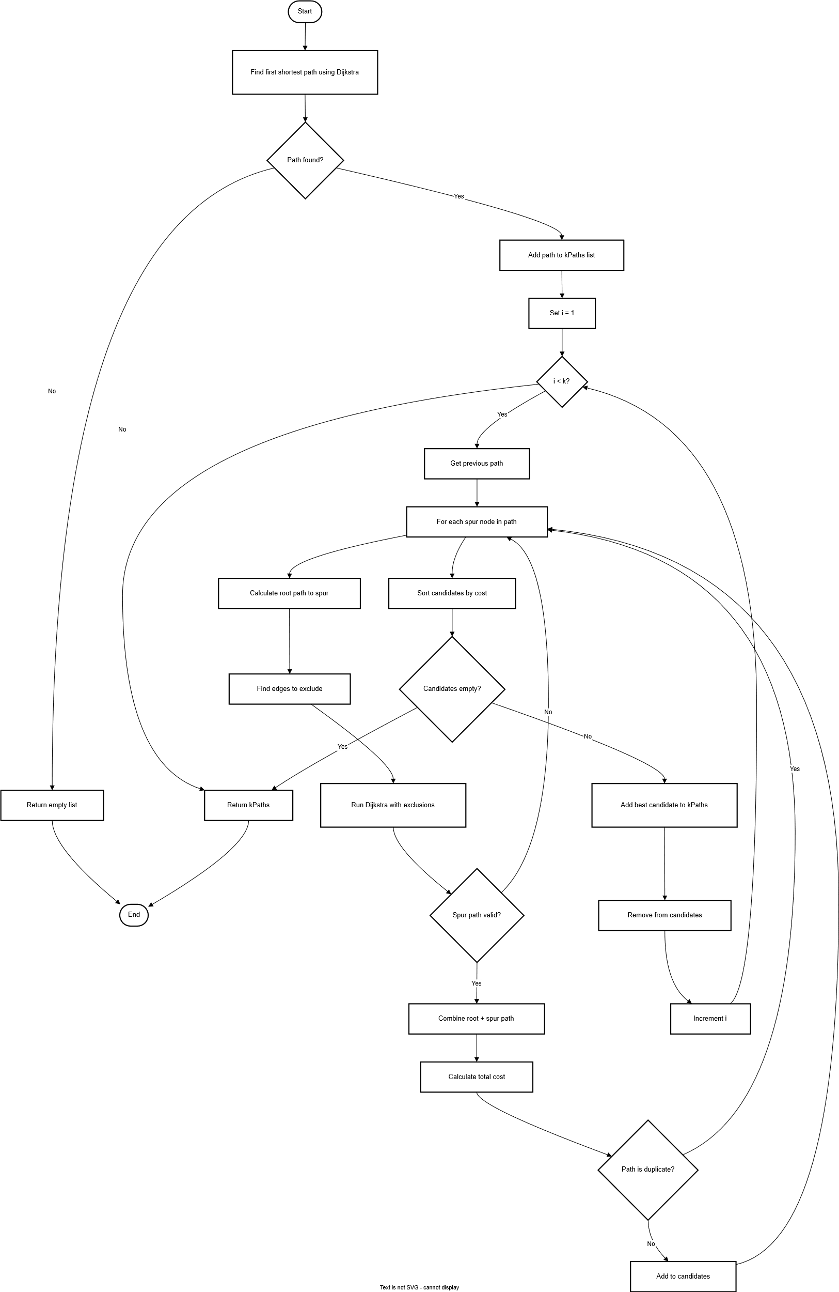

Figure 6 K-Shortest Path Algorithm Flowchart

## Record Delivery Attempt Flowchart

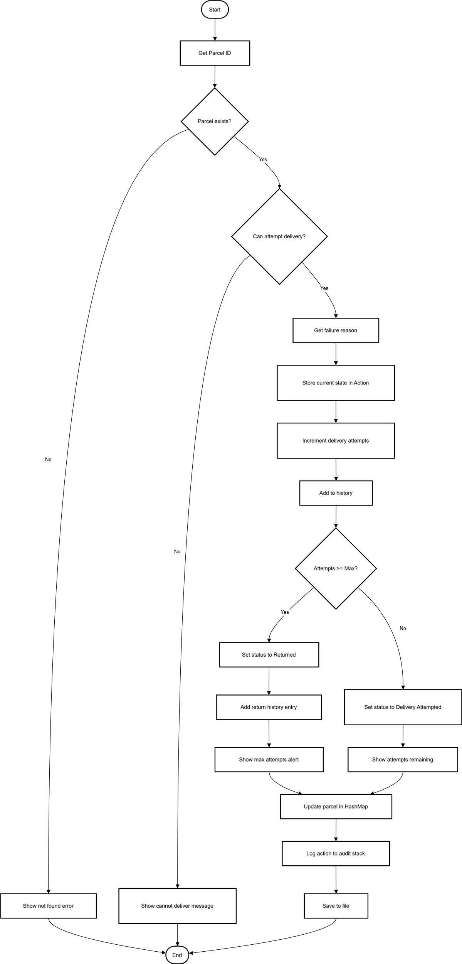

Figure Record Delivery Attempt Flowchart

## Assign Parcel to Rider Flowchart

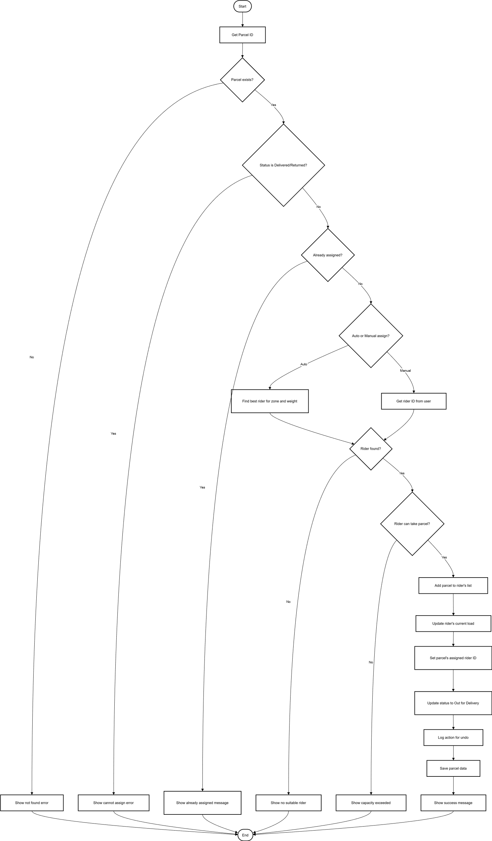

Figure 8 Assign Parcel to Rider Flowchart

## Find Best Rider Flowchart

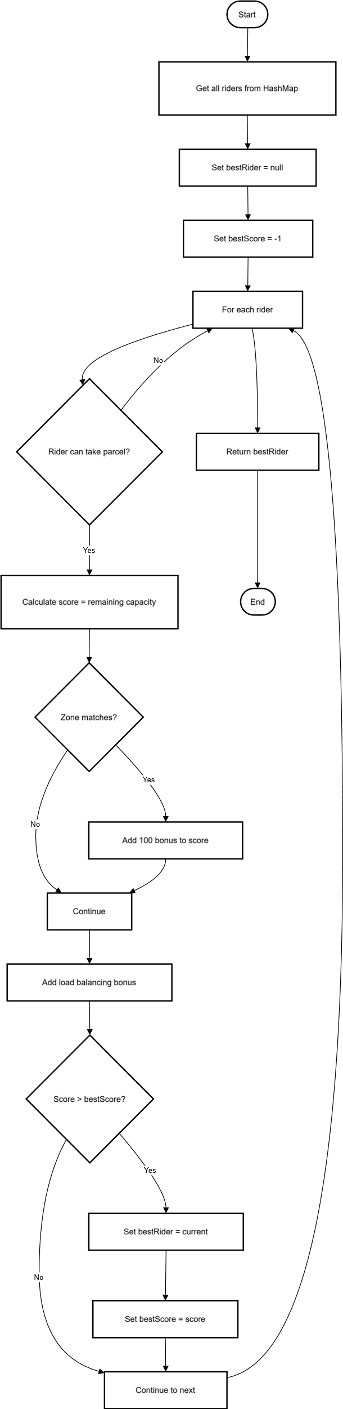

Figure 9 Find Best Rider Algorithm

## Undo Operation Flowchart

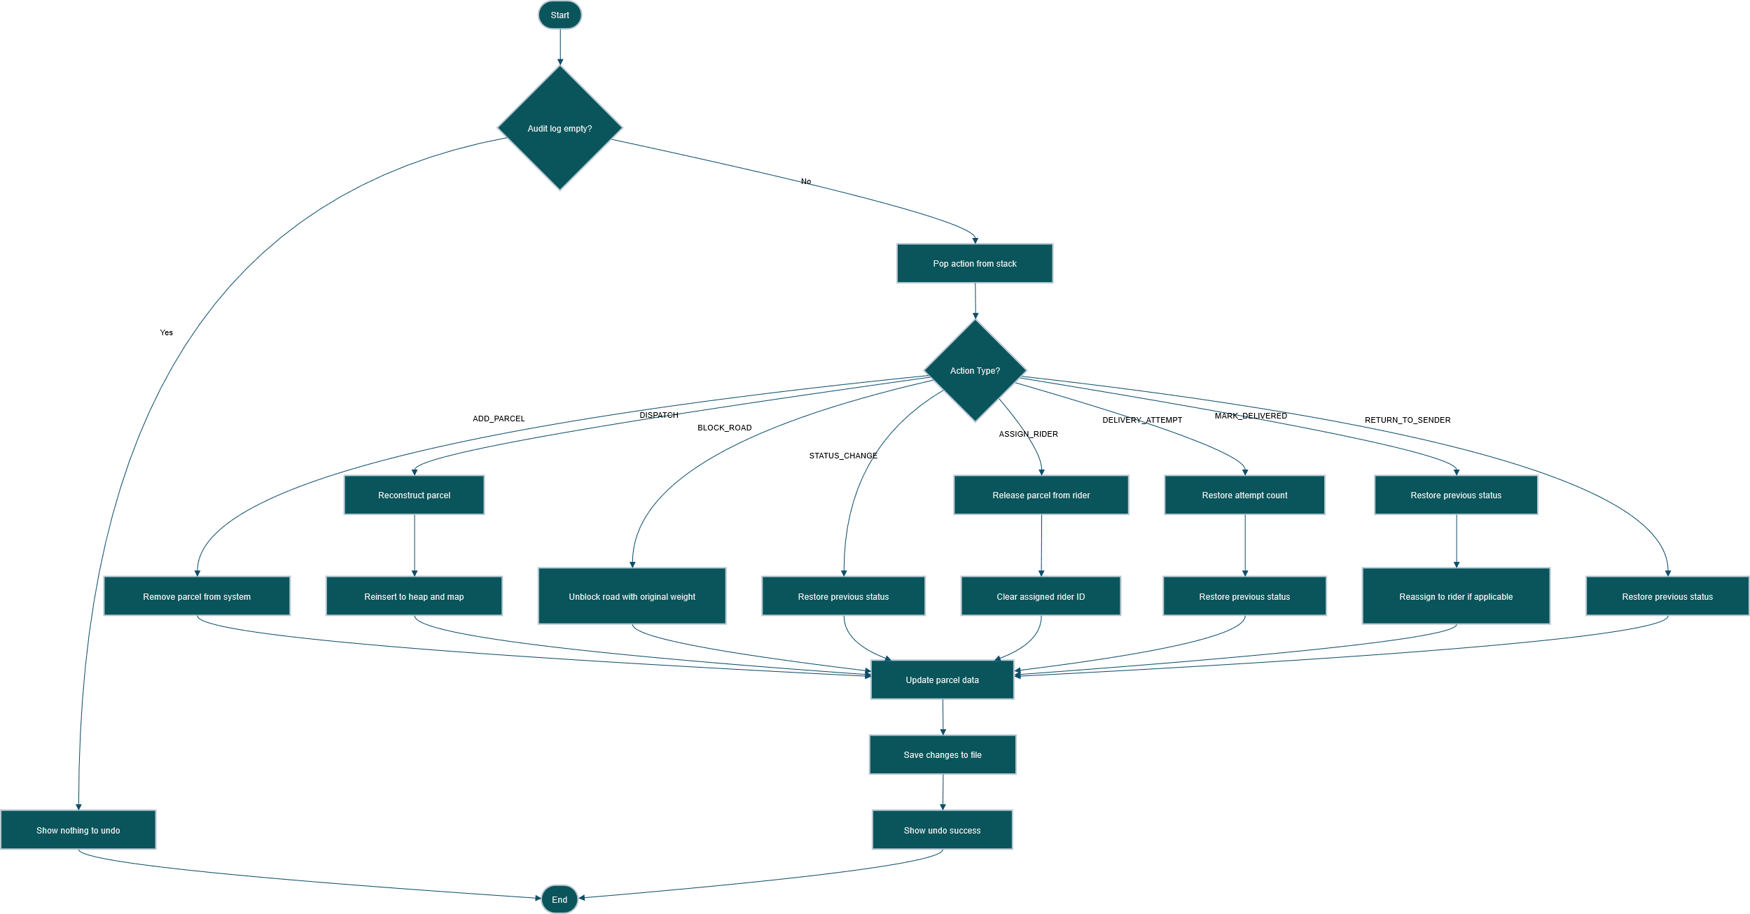

Figure 10 Undo Operation Flowchart

## Block/Unblock Road Flowchart

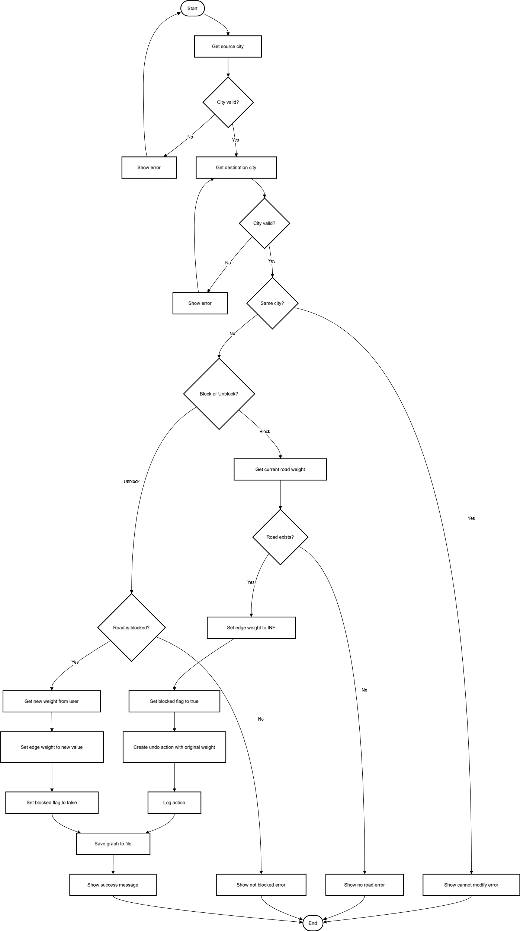

Figure Block/Unblock Road Flowchart

## Parcel Lifecycle Flowchart

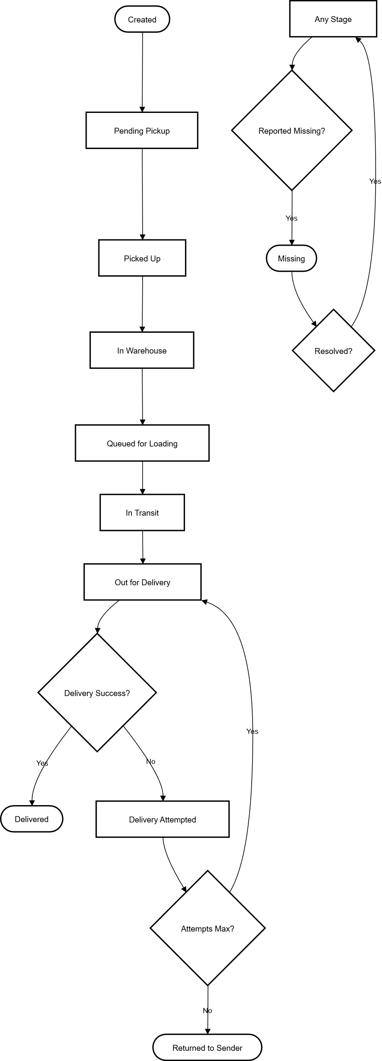

Figure Parcel Lifecycle Flowchart

## Queue Operations (Pickup/Warehouse/Transit) Flowchart

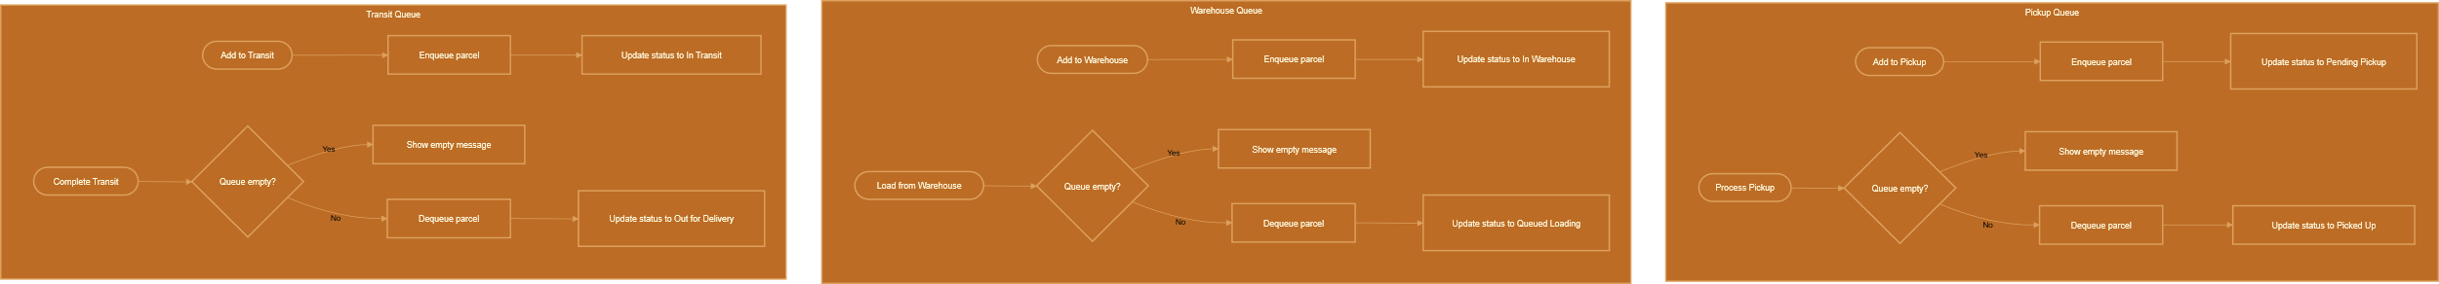

Figure 13 Queue Operations (Pickup/Warehouse/Transit) Flowchart

## MinHeap Insert Operation Flowchart

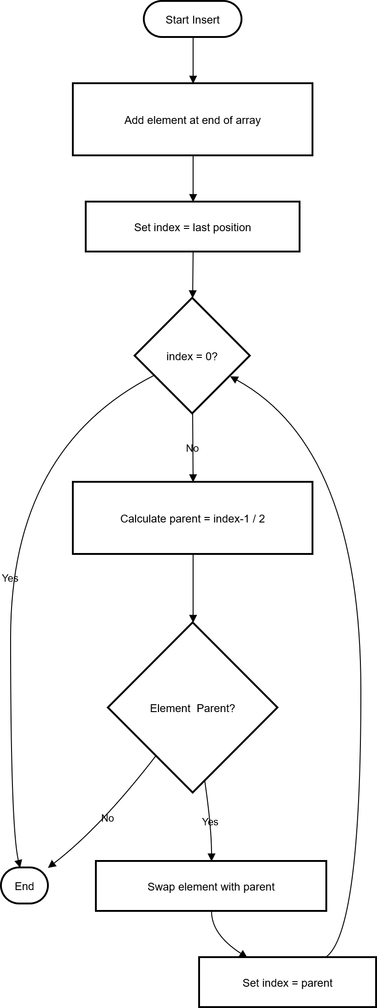

Figure 14 MinHeap Insert Operation

## MinHeap Extract Min Operation Flowchart

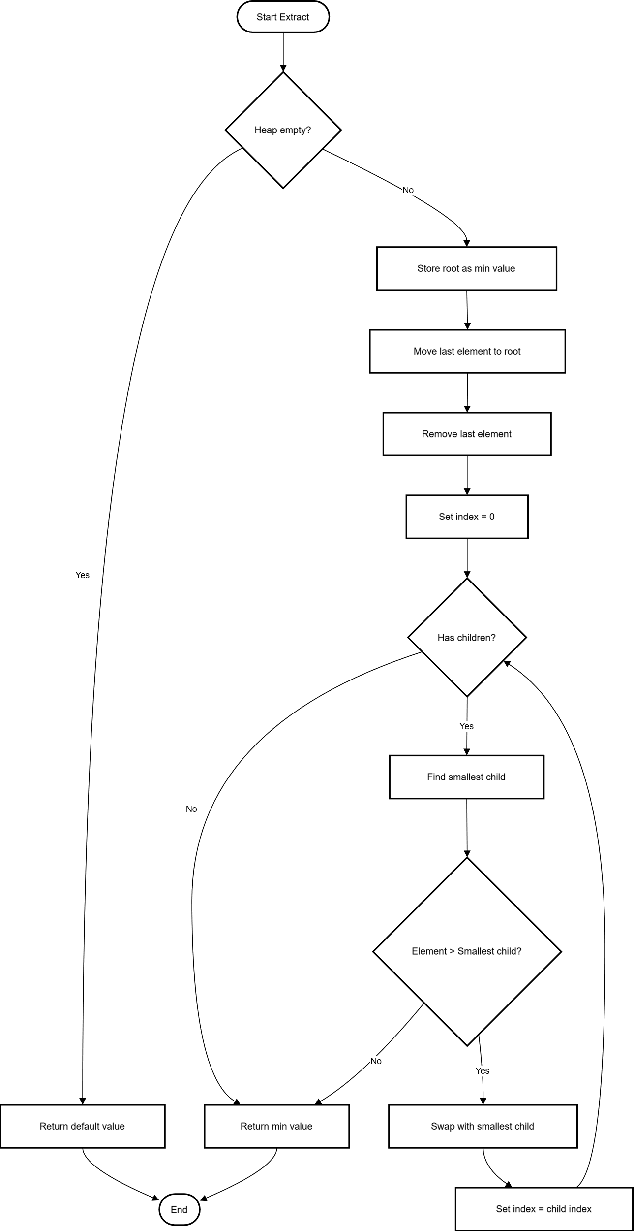

Figure 15MinHeap Extract Min Operation Flowchart

## HashMap Insert Operation Flowchart

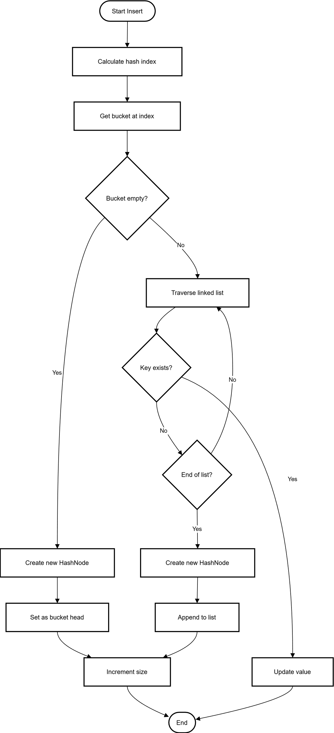

Figure 16 HashMap Insert Operation Flowchart

## Zone Auto-Assignment Flowchart

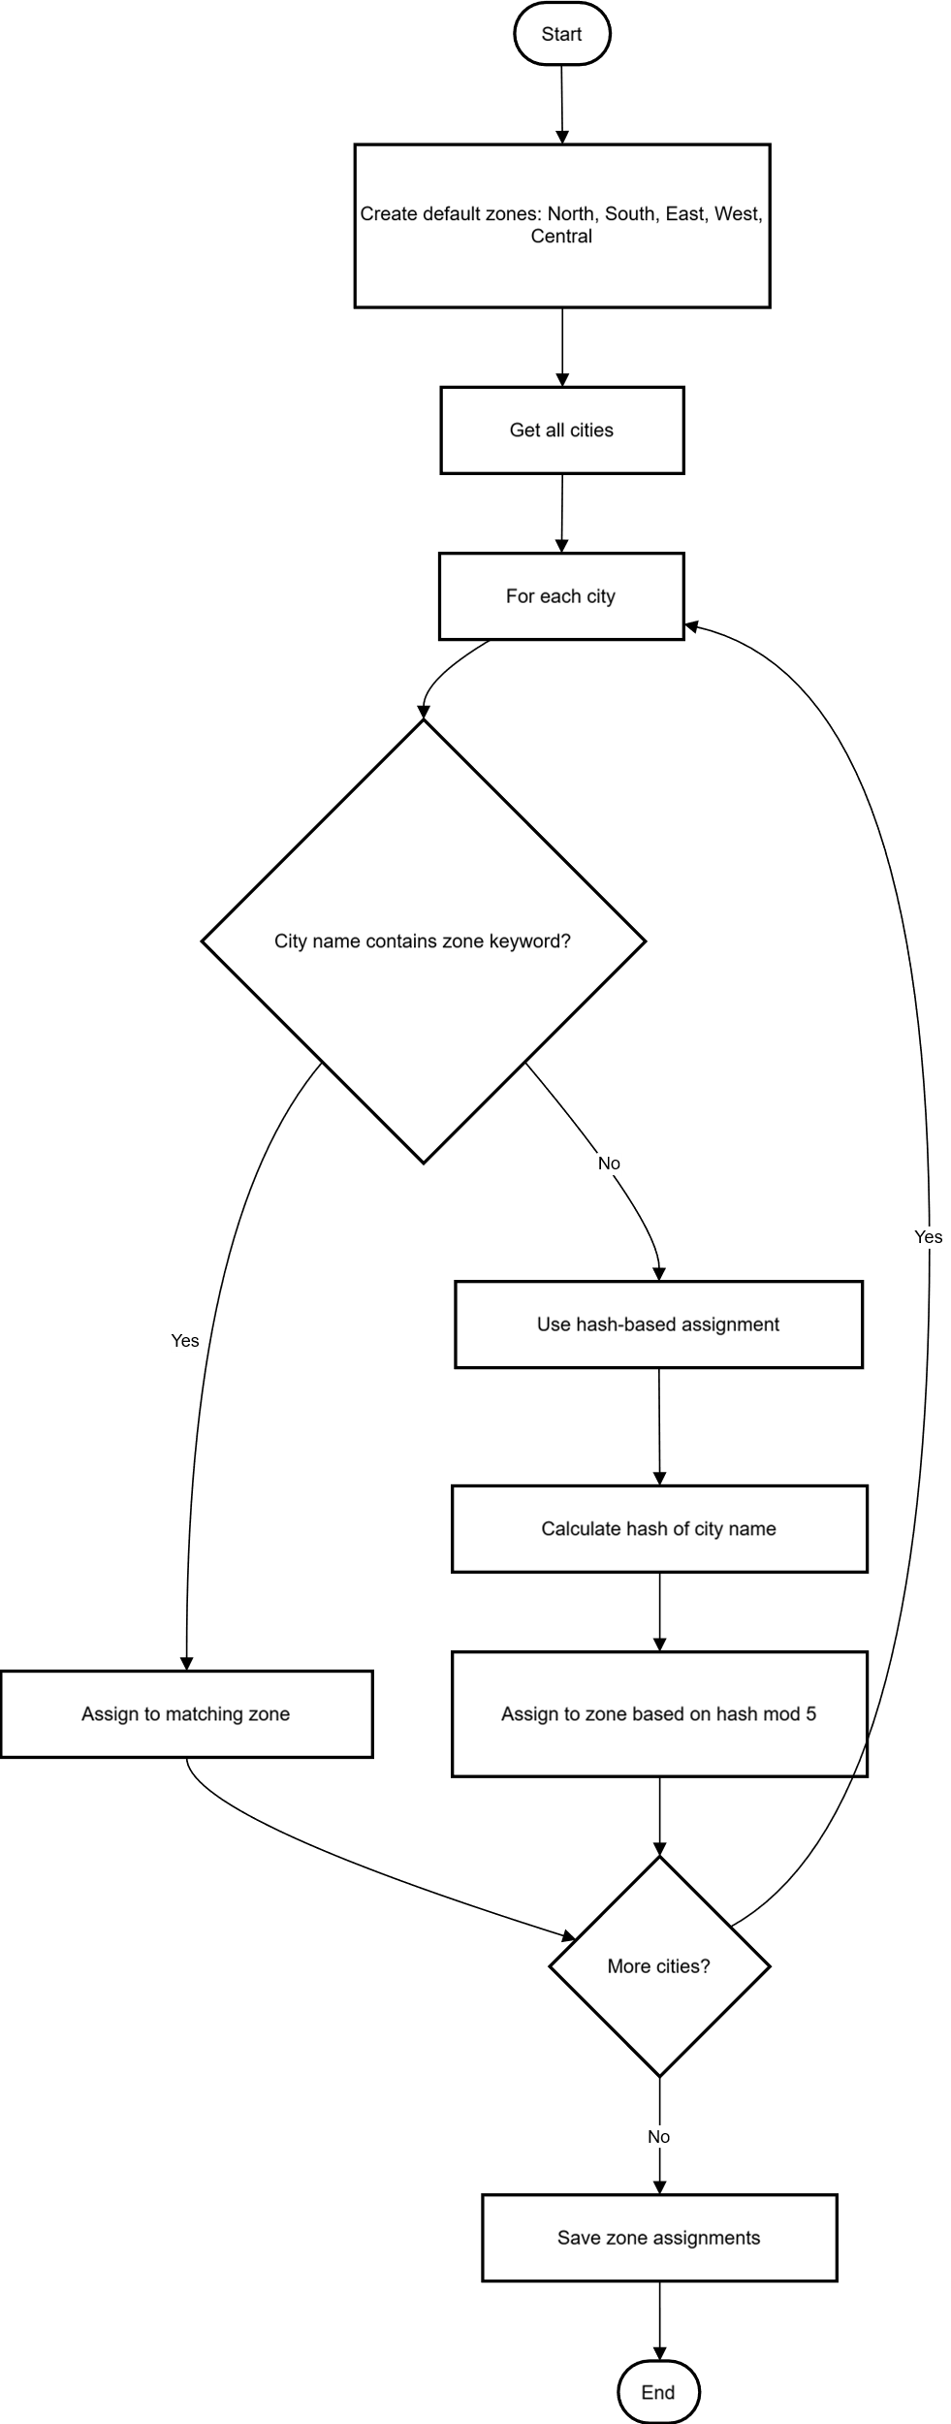

Figure 17 Zone Auto-Assignment Flowchart

## Save/Load Parcels Flowchart

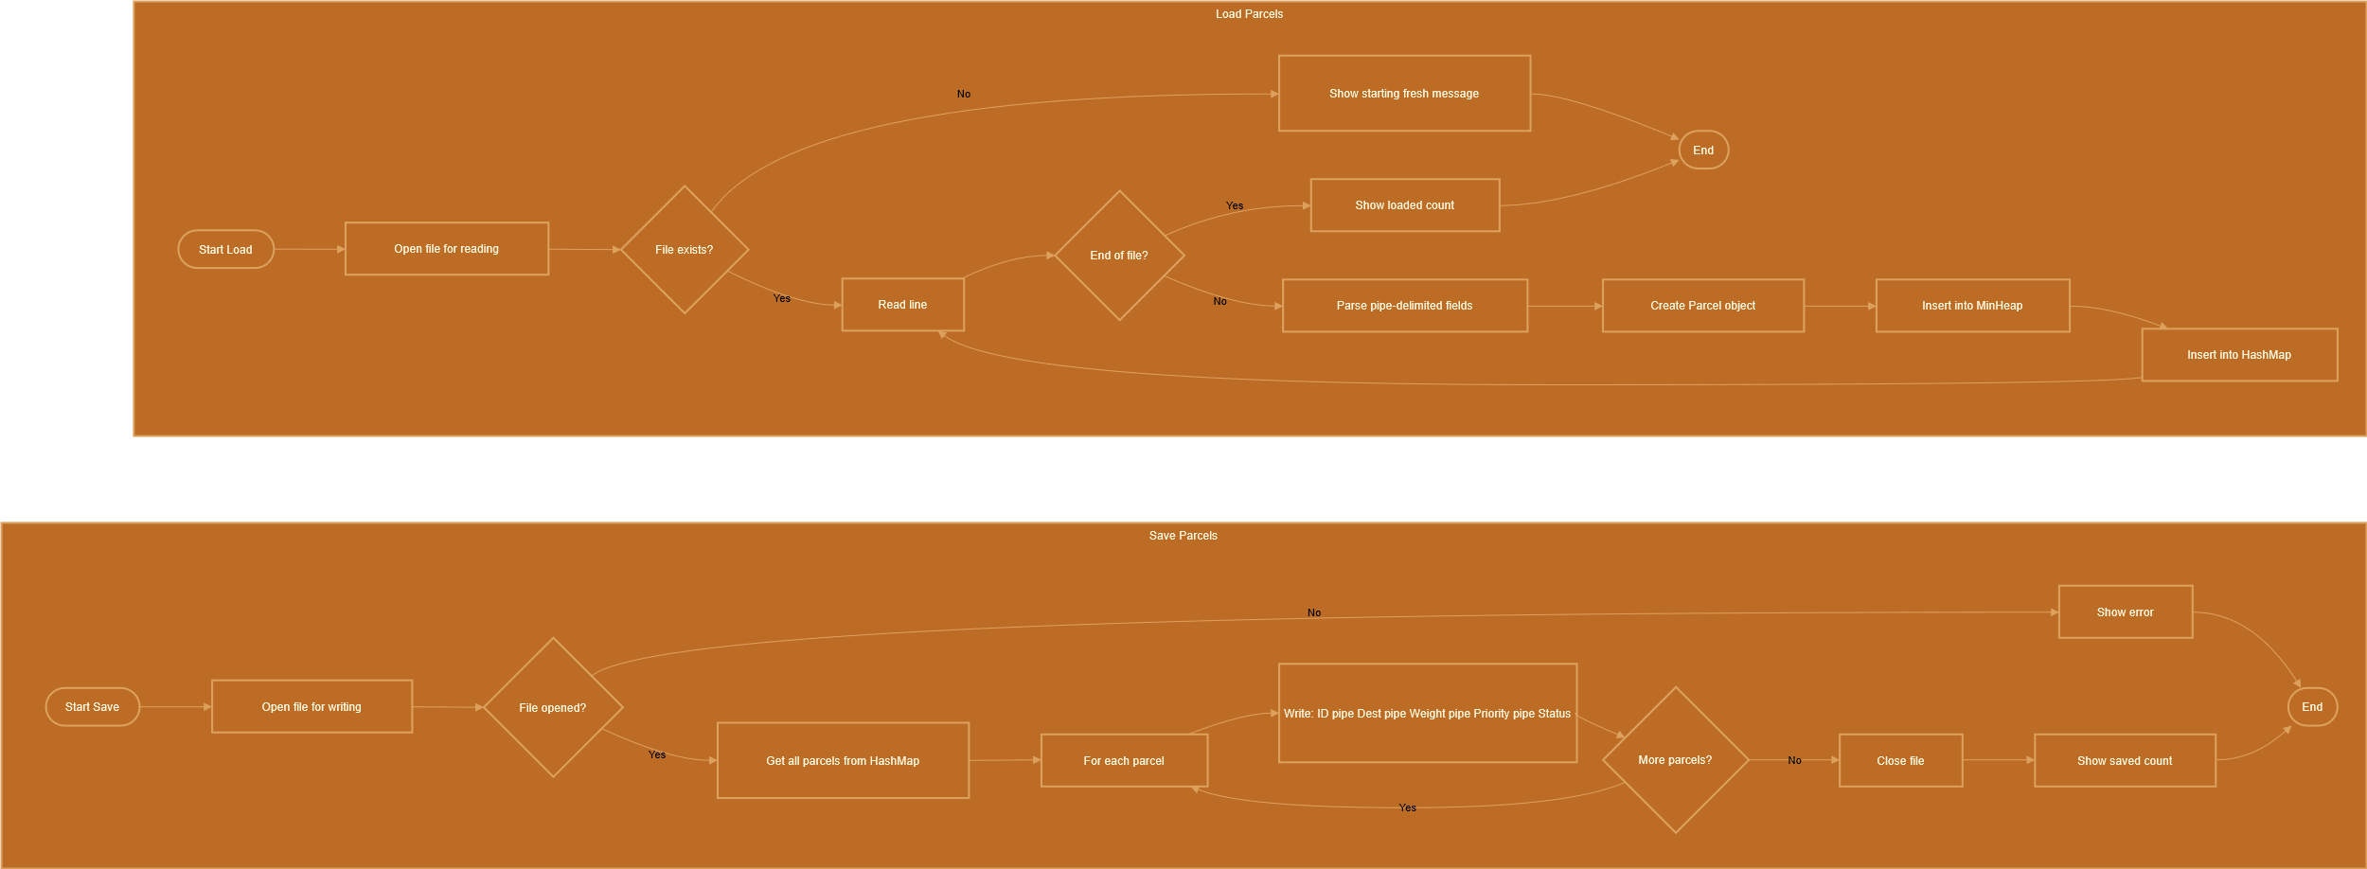

Figure 18 Save/Load Parcels Flowchart

## WebServer Request Handling Flowchart

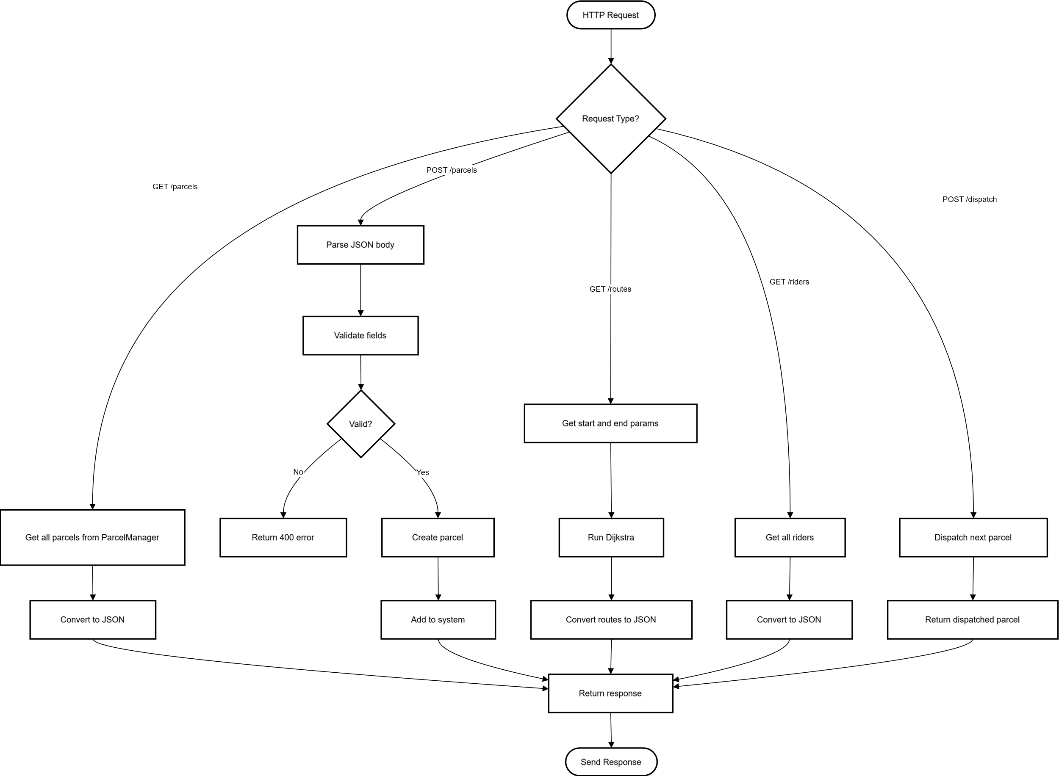

Figure 19 WebServer Request Handling Flowchart

# System Architecture Diagram

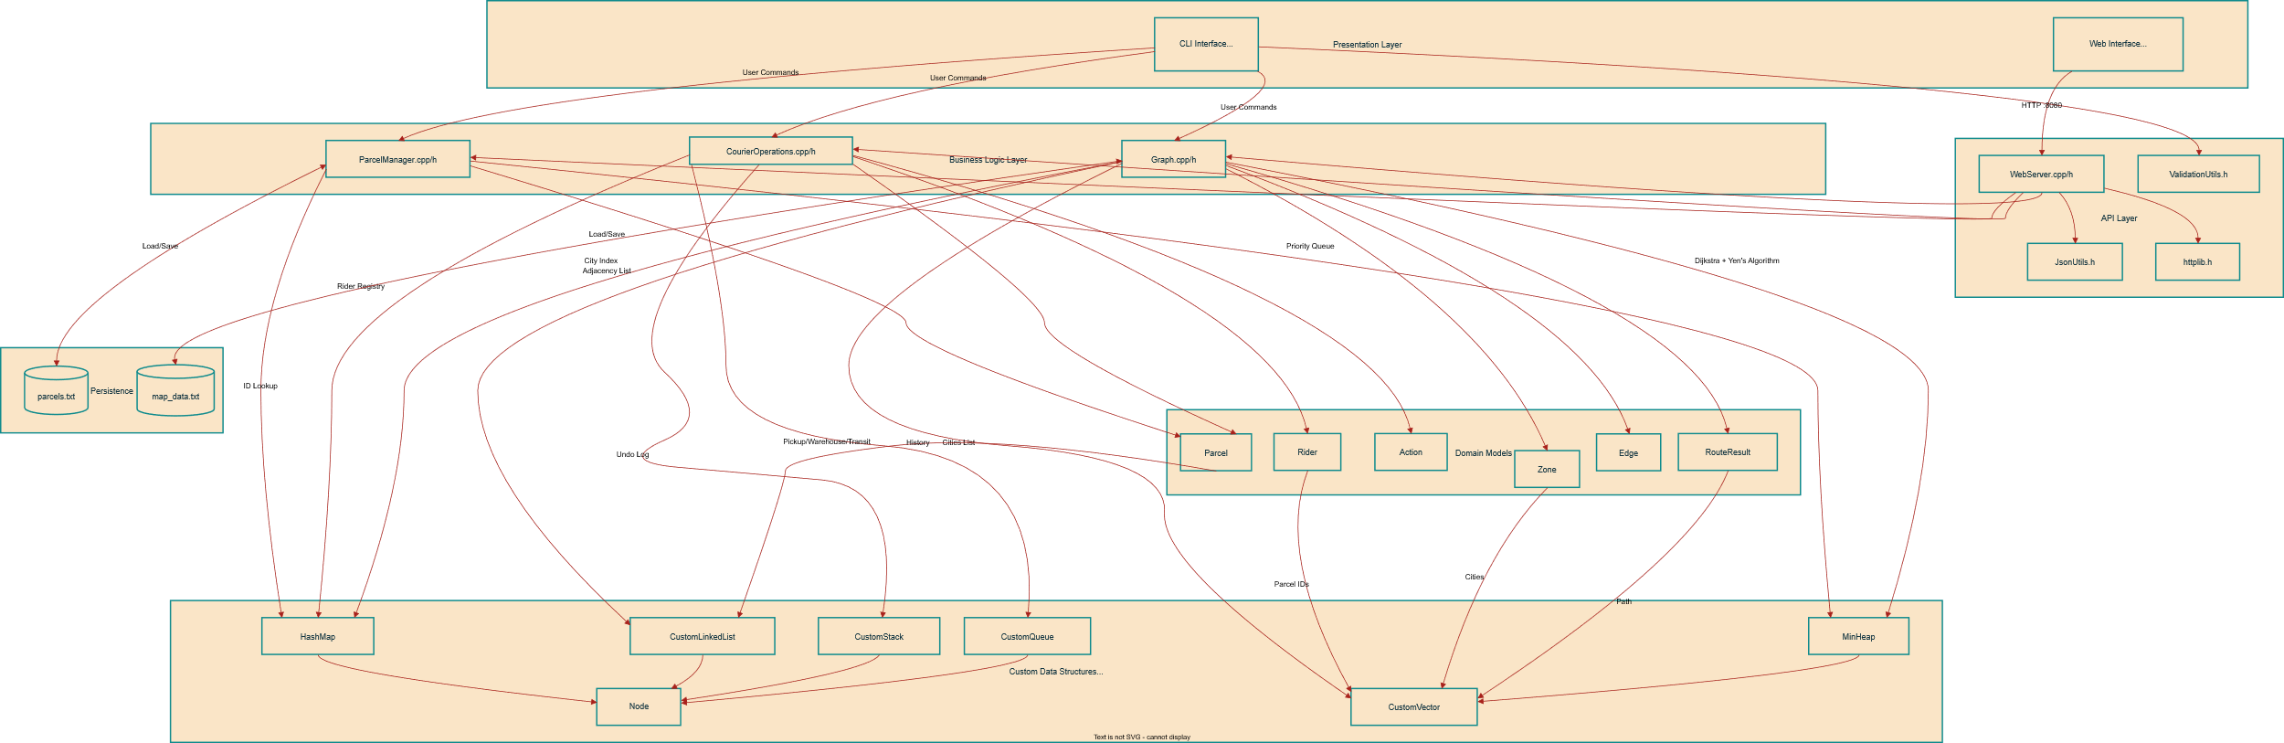

Figure 20 System Architecture Diagram

# System Architecture

The system follows a modular architecture, where each major functionality is implemented in a separate module. This improves readability, maintainability, and scalability.

**Core Modules**

* Intelligent Parcel Sorting Module
* Parcel Routing Module
* Parcel Tracking System Module
* Courier Operations Engine Module

# File and Module Description

## main.cpp

* *Entry point* of the application.
* Supports dual modes:
  + CLI Mode: Menu-driven console interface with 19+ options
  + Web Mode: REST API server (launch with --web flag)
* Coordinates interaction between all modules.
* Loads map data (map_data.txt) and parcel data (parcels.txt) at startup.
* Initializes default riders (Ali, Ahmed, Sara).
* Controls overall system flow including:
  + Parcel management (add, search, dispatch)
  + Delivery operations (attempts, mark delivered, return to sender)
  + Queue management (pickup, warehouse, transit)
  + Routing & zone management
  + Rider assignment
  + Undo functionality

## Parcel.h

* Defines the Parcel class with encapsulated attributes.
* Stores attributes:
  + Parcel ID
  + Priority (1=Overnight, 2=2-Day, 3=Normal)
  + Weight & Weight Category (Light/Medium/Heavy)
  + Destination & Zone
  + Current status (Created, Pending Pickup, In Transit, Delivered, etc.)
  + Delivery attempts tracking (max 3 attempts)
  + Sender address (for return-to-sender)
  + Assigned rider ID
  + History log (using CustomLinkedList)
* Provides getter/setter methods and status constants.
* Includes helper functions: *getWeightCategory(), getWeightCategoryName(), getCurrentTimestamp()*.

## ParcelManager.h / ParcelManager.cpp

* Responsible for parcel storage, sorting, and tracking.
* Uses MinHeap for priority-based parcel queue.
* Uses HashMap for O(1) parcel lookup by ID.
* Supports:
  + Insertion and removal of parcels
  + Priority-based dispatching (dispatchNext())
  + Duplicate ID checking (parcelExists())
  + Status updates throughout parcel lifecycle
  + Re-insertion for undo operations
  + File I/O: saveParcels() / loadParcels() for persistence.

## Graph.h / Graph.cpp

* Implements a weighted Graph representing the delivery network.
* Uses adjacency list representation (CustomVector of CustomLinkedList).
* Uses HashMap for O(1) city name lookup.
* Key features:
  + Nodes represent cities/locations
  + Edges represent roads with weights (distance/cost)
  + Road blocking/unblocking for route simulation
* Routing algorithms:
  + Dijkstra's algorithm for shortest path
  + Yen's K-Shortest Paths algorithm for alternative routes
* Zone Management:
  + Add/manage zones (North, South, East, West, Central)
  + Assign cities to zones
  + Auto-assign zones based on city configuration
* File I/O: loadGraph() / saveGraph() for map persistence. **structures.h**.

## CourierOperations.h / CourierOperations.cpp

* Simulates complete courier workflow using custom data structures.
* Queue Management (using CustomQueue):
  + Pickup Queue: Parcels waiting to be collected
  + Warehouse Queue: Parcels staged for loading
  + Transit Queue: Parcels currently being delivered
* Rider Class: Manages courier capacity, load, zone assignment.
* Rider Management (using HashMap):
  + Add/find riders
  + Find best rider by capacity and zone
  + Assign/release parcels from riders
* Missing Parcel Detection: Track and resolve missing parcels.
* Undo System (using CustomStack):
  + Action class stores operation type and state
  + Supports undo for: add parcel, dispatch, block road, status changes, rider assignment, delivery attempts
  + Full audit log of all actions.

## structures.h

* Contains custom data structure implementations (no STL):
  + Node<T>: Generic node for linked structures
  + CustomVector<T>: Dynamic array with auto-resize
  + CustomLinkedList<T>: Doubly linked list
  + CustomStack<T>: LIFO stack
  + CustomQueue<T>: FIFO queue
  + MinHeap<T>: Priority queue (min-heap)
  + HashMap<K, V>: Hash table with chaining
* Used across all modules for consistency.
* Includes copy constructors and assignment operators.

## ValidationUtils.h

* Provides input validation utilities in Utils namespace.
* Functions include:
  + getIntInput(): Validated integer input with range checking
  + getStringInput(): Non-empty single word input
  + getLineInput(): Full line input with spaces
  + getValidCity(): Validates city exists in graph
  + getAlphanumericInput(): Alphanumeric string validation
  + clearInputBuffer(): Safe input buffer clearing (handles EOF)
* Ensures safe and correct user input handling.
* Prevents invalid data processing in CLI mode.

## WebServer.h / WebServer.cpp

* Implements REST API server using httplib library.
* Endpoints for:
  + Parcel management (CRUD operations)
  + Queue operations (pickup, warehouse, transit)
  + Rider management
  + Route finding and zone management
  + System status
* Serves static files from public/ folder.
* Enables web-based UI interaction.

## JsonUtils.h

* Provides JSON serialization utilities for web API.
* Converts Parcel, Rider, and Route objects to JSON format.
* Used by WebServer for API responses.

## Input/Output Files

* map_data.txt → Stores delivery network:
  + CITY <name>: Define city nodes
  + ROUTE <from> <to> <weight>: Define weighted edges
  + ZONE <name>: Define delivery zones
  + ZONECITY <zone> <city>: Assign city to zone
* parcels.txt → Stores parcel data (pipe-delimited):
  + Format: ID | Destination | Weight | Priority | Status

## public/ (Web UI)

* index.html: Main web interface page
* styles.css: Styling for web UI

# Data Structures and Algorithms Justification

## Data Structures Used:

|  |  |  |
| --- | --- | --- |
| Module | Data Structure | Purpose |
| Parcel Management | MinHeap | Priority-based parcel dispatching (O(log n) insert/extract) |
| Parcel Management | HashMap<int, Parcel> | O(1) parcel lookup by ID |
| Routing | Graph (Adjacency List) | Represents road network with weighted edges |
| Routing | HashMap<string, int> | O(1) city name to index lookup |
| Parcel Tracking | CustomLinkedList | Maintains parcel status history log |
| Pickup Operations | CustomQueue | FIFO processing of pickup requests |
| Warehouse Operations | CustomQueue | FIFO staging of parcels for loading |
| Transit Operations | CustomQueue | FIFO tracking of in-transit parcels |
| Undo System | CustomStack | LIFO audit log for operation reversal |
| Rider Management | HashMap<int, Rider> | O(1) rider lookup and management |
| Missing Parcels | HashMap<int, Parcel> | Track potentially missing parcels |
| Zone Management | HashMap<string, Zone> | Zone storage and lookup |
| City-Zone Mapping | HashMap<string, string> | O(1) city to zone resolution |
| Dynamic Storage | CustomVector | Auto-resizing arrays for flexible storage |

## Algorithms Used:

|  |  |  |
| --- | --- | --- |
| Algorithm | Module | Purpose |
| Dijkstra's Algorithm | Graph.cpp | Find shortest path between cities |
| Yen's K-Shortest Paths | Graph.cpp | Find K alternative routes for delivery |
| Heap Operations (Heapify) | structures.h | Maintain priority queue property |
| Hash Function (Chaining) | structures.h | Collision resolution in HashMap |
| Linear Search | CustomVector | Find elements in dynamic arrays |
| Doubly Linked List Ops | CustomLinkedList | Efficient insert/delete at both ends |

## Complexity Analysis:

|  |  |  |
| --- | --- | --- |
| Operation | Time Complexity | Data Structure |
| Add Parcel | O(log n) | MinHeap |
| Dispatch Next (Priority) | O(log n) | MinHeap |
| Find Parcel by ID | O(1) average | HashMap |
| Shortest Path | O((V+E) log V) | Graph + MinHeap |
| K-Shortest Paths | O(K * V * (V+E) log V) | Yen's Algorithm |
| Enqueue/Dequeue | O(1) | CustomQueue |
| Push/Pop (Undo) | O(1) | CustomStack |
| Add to History | O(1) | CustomLinkedList |

# Conclusion

The Intelligent Courier Logistics Engine successfully simulates a real-world courier system using core Data Structures and Algorithms. Through modular design, efficient data handling, and algorithmic decision-making, the project demonstrates strong problem-solving skills and practical application of DSA concepts in C++.